Cisco ASA Firewall Lab with Inside, Outside, and DMZ1 Networks
This document provides a complete laboratory guide for configuring a Cisco ASA firewall using Inside, Outside, and DMZ1 security zones. The DMZ network hosts a public web server. The lab includes DHCP services, NAT, ACL filtering, web filtering, and IDS/IPS integration. Each configuration command is explained in detail to help students understand the purpose and behavior of the configuration.

1. Network Topology
The topology consists of three main security zones. The Inside network contains trusted users. The Outside network simulates the Internet. The DMZ network hosts public-facing services such as a web server.
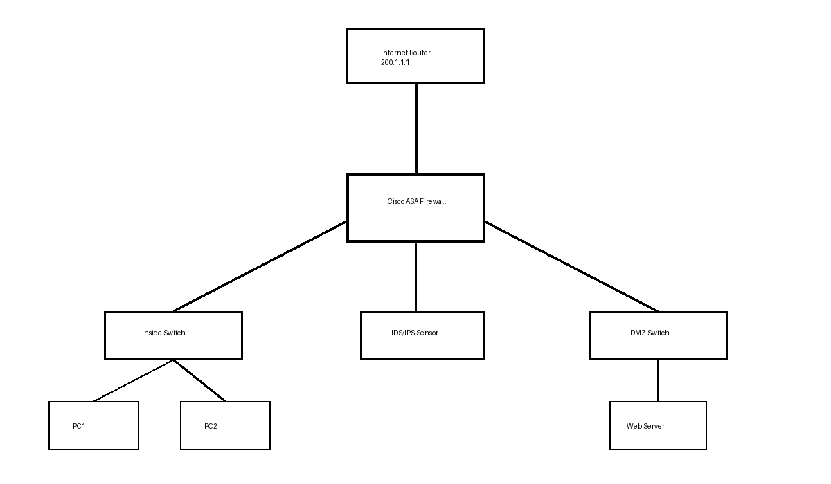

2. IP Addressing Plan
Zone | Device | Interface | IP Address
Outside | Internet Router | G0/0 | 200.1.1.1/24
Outside | Cisco ASA | G0/0 | 200.1.1.2/24
Inside | Cisco ASA | G0/1 | 192.168.10.1/24
Inside | PC1 and PC2 | DHCP | 192.168.10.50+
DMZ1 | Cisco ASA | G0/2 | 172.16.1.1/24
DMZ1 | Web Server | NIC | 172.16.1.100/24

3. Packet Tracer Topology Construction Guide
- Open Cisco Packet Tracer and create a new project.
- Add one Cisco ASA firewall to the workspace.
- Add one router to simulate the Internet connection.
- Add two switches to represent the Inside and DMZ networks.
- Add two PCs to the Inside switch.
- Add one web server to the DMZ switch.
- Add an optional IDS/IPS sensor.
- Connect all devices using copper straight-through cables.
- Assign IP addresses according to the addressing table.
- Enable HTTP and HTTPS services on the web server.

4. ASA Basic Configuration
enable
Enters privileged EXEC mode to allow administrative configuration.
configure terminal
Enters global configuration mode.
hostname ASA-FW
Changes the firewall hostname to ASA-FW.
interface gigabitEthernet0/0
Selects the outside interface connected to the Internet.
nameif outside
Assigns the logical name 'outside' to the interface.
security-level 0
Sets the security level to 0, representing the least trusted network.
ip address 200.1.1.2 255.255.255.0
Assigns the IP address to the outside interface.
no shutdown
Enables the interface.
interface gigabitEthernet0/1
Selects the inside interface.
nameif inside
Assigns the logical name 'inside'.
security-level 100
Sets the highest trust level for internal users.
ip address 192.168.10.1 255.255.255.0
Assigns the gateway IP address for Inside users.
interface gigabitEthernet0/2
Selects the DMZ interface.
nameif dmz1
Assigns the logical name dmz1.
security-level 50
Assigns a medium trust level to the DMZ.
ip address 172.16.1.1 255.255.255.0
Assigns the gateway IP address for the DMZ network.

5. DHCP Configuration
dhcpd address 192.168.10.50-192.168.10.100 inside
Creates a DHCP pool for Inside users.
dhcpd dns 208.67.222.222 208.67.220.220 interface inside
Assigns DNS servers to DHCP clients.
dhcpd domain lab.local
Assigns a domain name to DHCP clients.
dhcpd enable inside
Enables the DHCP service on the Inside interface.

6. NAT Configuration
object network INSIDE-NET
Creates a network object for the Inside network.
subnet 192.168.10.0 255.255.255.0
Defines the subnet belonging to the Inside network object.
nat (inside,outside) dynamic interface
Configures PAT so Inside users can access the Internet using the ASA outside IP.
object network WEB-SERVER
Creates a network object for the DMZ web server.
host 172.16.1.100
Defines the IP address of the DMZ web server.
nat (dmz1,outside) static 200.1.1.100
Maps the internal web server to a public IP address.

7. ACL Configuration
access-list OUTSIDE-IN extended permit tcp any host 172.16.1.100 eq 80
Allows HTTP traffic from the Internet to the DMZ web server.
access-list OUTSIDE-IN extended permit tcp any host 172.16.1.100 eq 443
Allows HTTPS traffic from the Internet to the DMZ web server.
access-list OUTSIDE-IN extended deny ip any 192.168.10.0 255.255.255.0
Blocks all direct access attempts to the Inside network.
access-list OUTSIDE-IN extended deny tcp any any eq 23
Blocks Telnet traffic for security purposes.
access-list OUTSIDE-IN extended deny ip any any
Blocks all remaining traffic not explicitly permitted.
access-group OUTSIDE-IN in interface outside
Applies the ACL to inbound traffic on the outside interface.

8. Web Filtering Configuration
access-list WEB-FILTER extended deny tcp any host 157.240.0.0 eq 80
Blocks HTTP access to selected websites.
access-list WEB-FILTER extended deny tcp any host 157.240.0.0 eq 443
Blocks HTTPS access to selected websites.
access-list WEB-FILTER extended permit tcp any any eq 80
Allows general HTTP traffic.
access-list WEB-FILTER extended permit tcp any any eq 443
Allows general HTTPS traffic.

9. IDS/IPS Integration
The IDS/IPS device monitors network traffic for malicious activities such as port scanning, SQL injection attempts, malware communication, and ICMP flooding. The IDS/IPS can be deployed inline or passively depending on the organization’s security policy.

10. Suggested Verification Commands
show interface ip brief
Displays the status and IP addresses of interfaces.
show access-list
Displays ACL entries and packet counters.
show nat
Displays configured NAT rules.
show conn
Displays active connections through the firewall.
show dhcpd binding
Displays DHCP-assigned addresses.

11. Security Testing Scenarios
- Verify that Inside PCs receive IP addresses automatically.
- Verify that Inside users can browse the Internet.
- Verify that HTTP and HTTPS access to the DMZ web server is successful.
- Verify that Telnet traffic is blocked.
- Verify that direct access from the Internet to the Inside network is denied.
- Verify that the IDS/IPS sensor detects suspicious traffic.

12. Conclusion
This laboratory demonstrates the implementation of a secure Cisco ASA firewall architecture using multiple security zones. The lab combines firewall filtering, NAT, DHCP, web filtering, and IDS/IPS integration to provide a realistic enterprise security deployment.

